Chinese Calendar
# Source: AI Source: Provided by: [Data Path: Persons Table -> ID Column: 1, Name_En Column: Motasem Essam] -> From: [ChatGPT] on [7/17/2026]
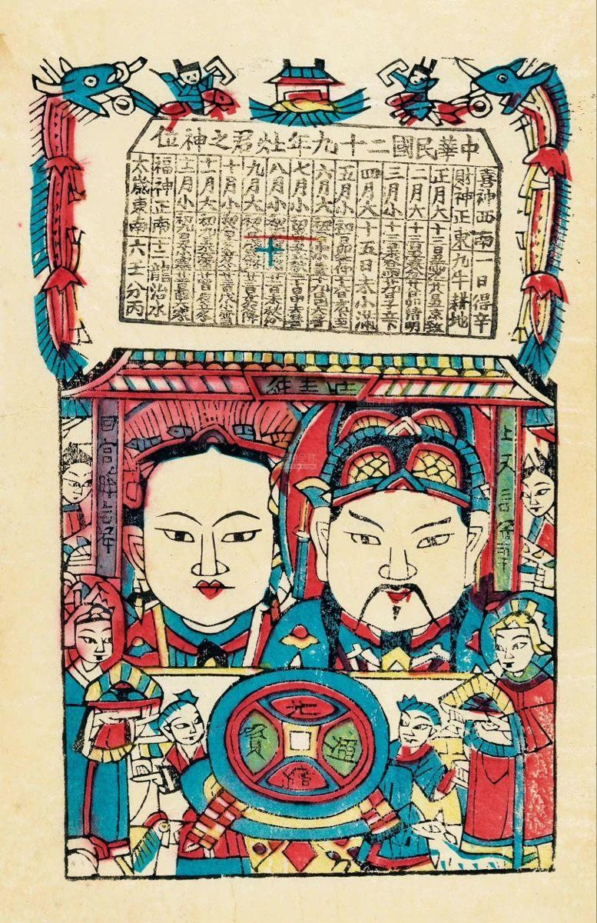
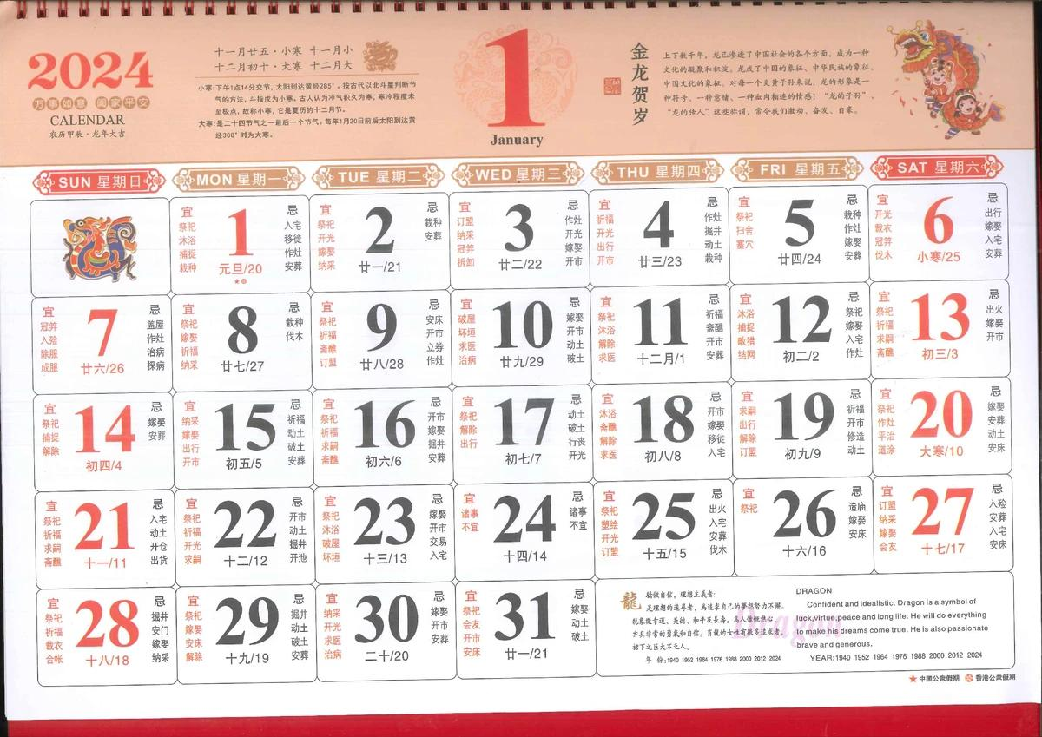
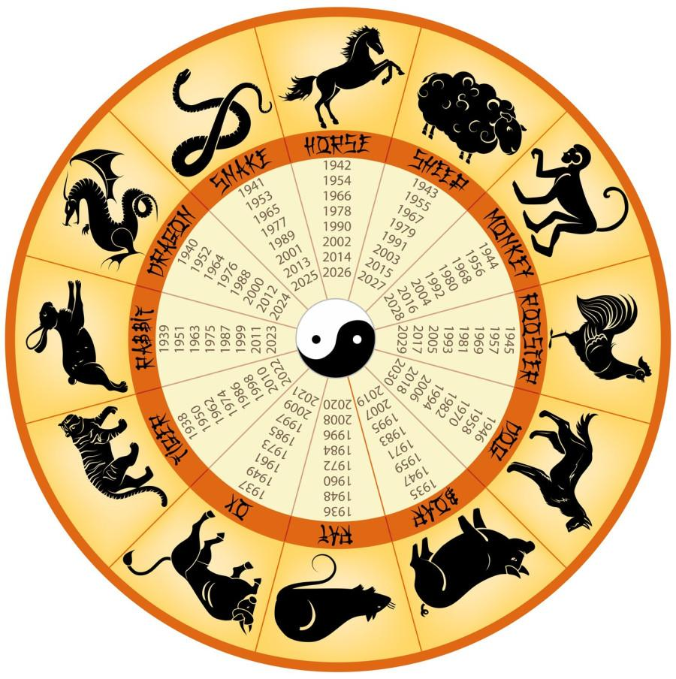
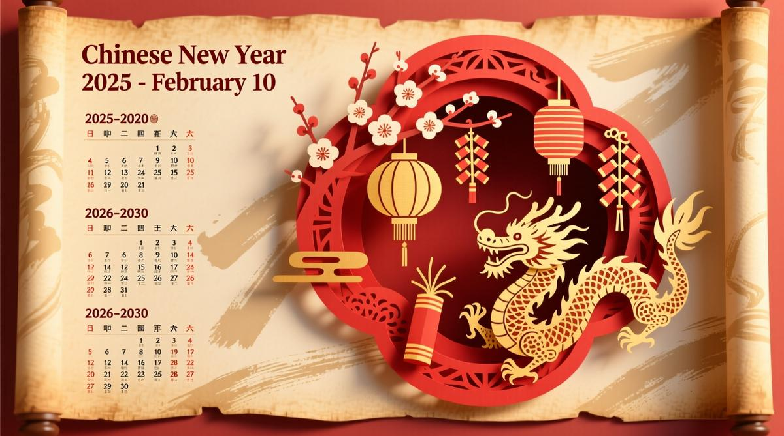
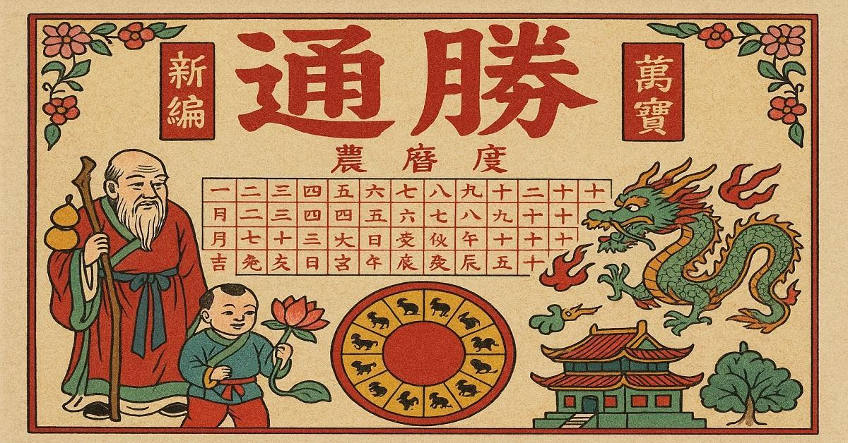
The Chinese Calendar is a lunisolar calendar that combines the phases of the Moon with the Earth's orbit around the Sun. It has been used in China for thousands of years to determine traditional festivals, agricultural activities, and cultural events.
Unlike a purely lunar calendar, the Chinese Calendar periodically adds a leap month to keep the calendar synchronized with the seasons.

Definition
# Source: AI Source: Provided by: [Data Path: Persons Table -> ID Column: 1, Name_En Column: Motasem Essam] -> From: [ChatGPT] on [7/17/2026]
The Chinese Calendar is a lunisolar calendar in which months follow the lunar cycle while leap months are added periodically to keep the calendar aligned with the solar year and the seasons.

Purpose
# Source: AI Source: Provided by: [Data Path: Persons Table -> ID Column: 1, Name_En Column: Motasem Essam] -> From: [ChatGPT] on [7/17/2026]
The Chinese Calendar is used to:
- Determine traditional Chinese festivals.
- Celebrate the Chinese New Year.
- Schedule cultural and religious events.
- Guide agricultural activities.
- Maintain seasonal alignment.
- Identify zodiac years.

History
# Source: AI Source: Provided by: [Data Path: Persons Table -> ID Column: 1, Name_En Column: Motasem Essam] -> From: [ChatGPT] on [7/17/2026]
The Chinese Calendar has a history of more than 3,000 years.
It was developed through astronomical observations and has been refined by successive Chinese dynasties.
Although the Gregorian Calendar is now used for official civil purposes in China, the traditional Chinese Calendar remains important for cultural and religious occasions.

Type of Calendar
# Source: AI Source: Provided by: [Data Path: Persons Table -> ID Column: 1, Name_En Column: Motasem Essam] -> From: [ChatGPT] on [7/17/2026]
The Chinese Calendar is a:
- Lunisolar Calendar
It is based on:
- The Moon for months.
- The Sun for maintaining seasonal alignment.

Structure of the Chinese Calendar
# Source: AI Source: Provided by: [Data Path: Persons Table -> ID Column: 1, Name_En Column: Motasem Essam] -> From: [ChatGPT] on [7/17/2026]
A normal year contains:
- 12 lunar months
- Approximately 354 days
A leap year contains:
- 13 months
- Approximately 383–385 days

Months
# Source: AI Source: Provided by: [Data Path: Persons Table -> ID Column: 1, Name_En Column: Motasem Essam] -> From: [ChatGPT] on [7/17/2026]
Unlike the Gregorian Calendar, months are traditionally numbered rather than given permanent names.
Example:
- First Month
- Second Month
- Third Month
- ...
- Twelfth Month
A leap month may occur between two numbered months and is identified as the Leap version of that month.

Leap Month
# Source: AI Source: Provided by: [Data Path: Persons Table -> ID Column: 1, Name_En Column: Motasem Essam] -> From: [ChatGPT] on [7/17/2026]
Because twelve lunar months are about 11 days shorter than the solar year, the Chinese Calendar periodically inserts a leap month.
This keeps:
- Lunar months
- Agricultural seasons
- Traditional festivals
properly aligned.

Relationship to the Seasons
# Source: AI Source: Provided by: [Data Path: Persons Table -> ID Column: 1, Name_En Column: Motasem Essam] -> From: [ChatGPT] on [7/17/2026]
The Chinese Calendar remains synchronized with the seasons.
For example:
- Chinese New Year always falls between late January and mid-February.
- Seasonal festivals remain in approximately the same part of the year.

Chinese Zodiac
# Source: AI Source: Provided by: [Data Path: Persons Table -> ID Column: 1, Name_En Column: Motasem Essam] -> From: [ChatGPT] on [7/17/2026]
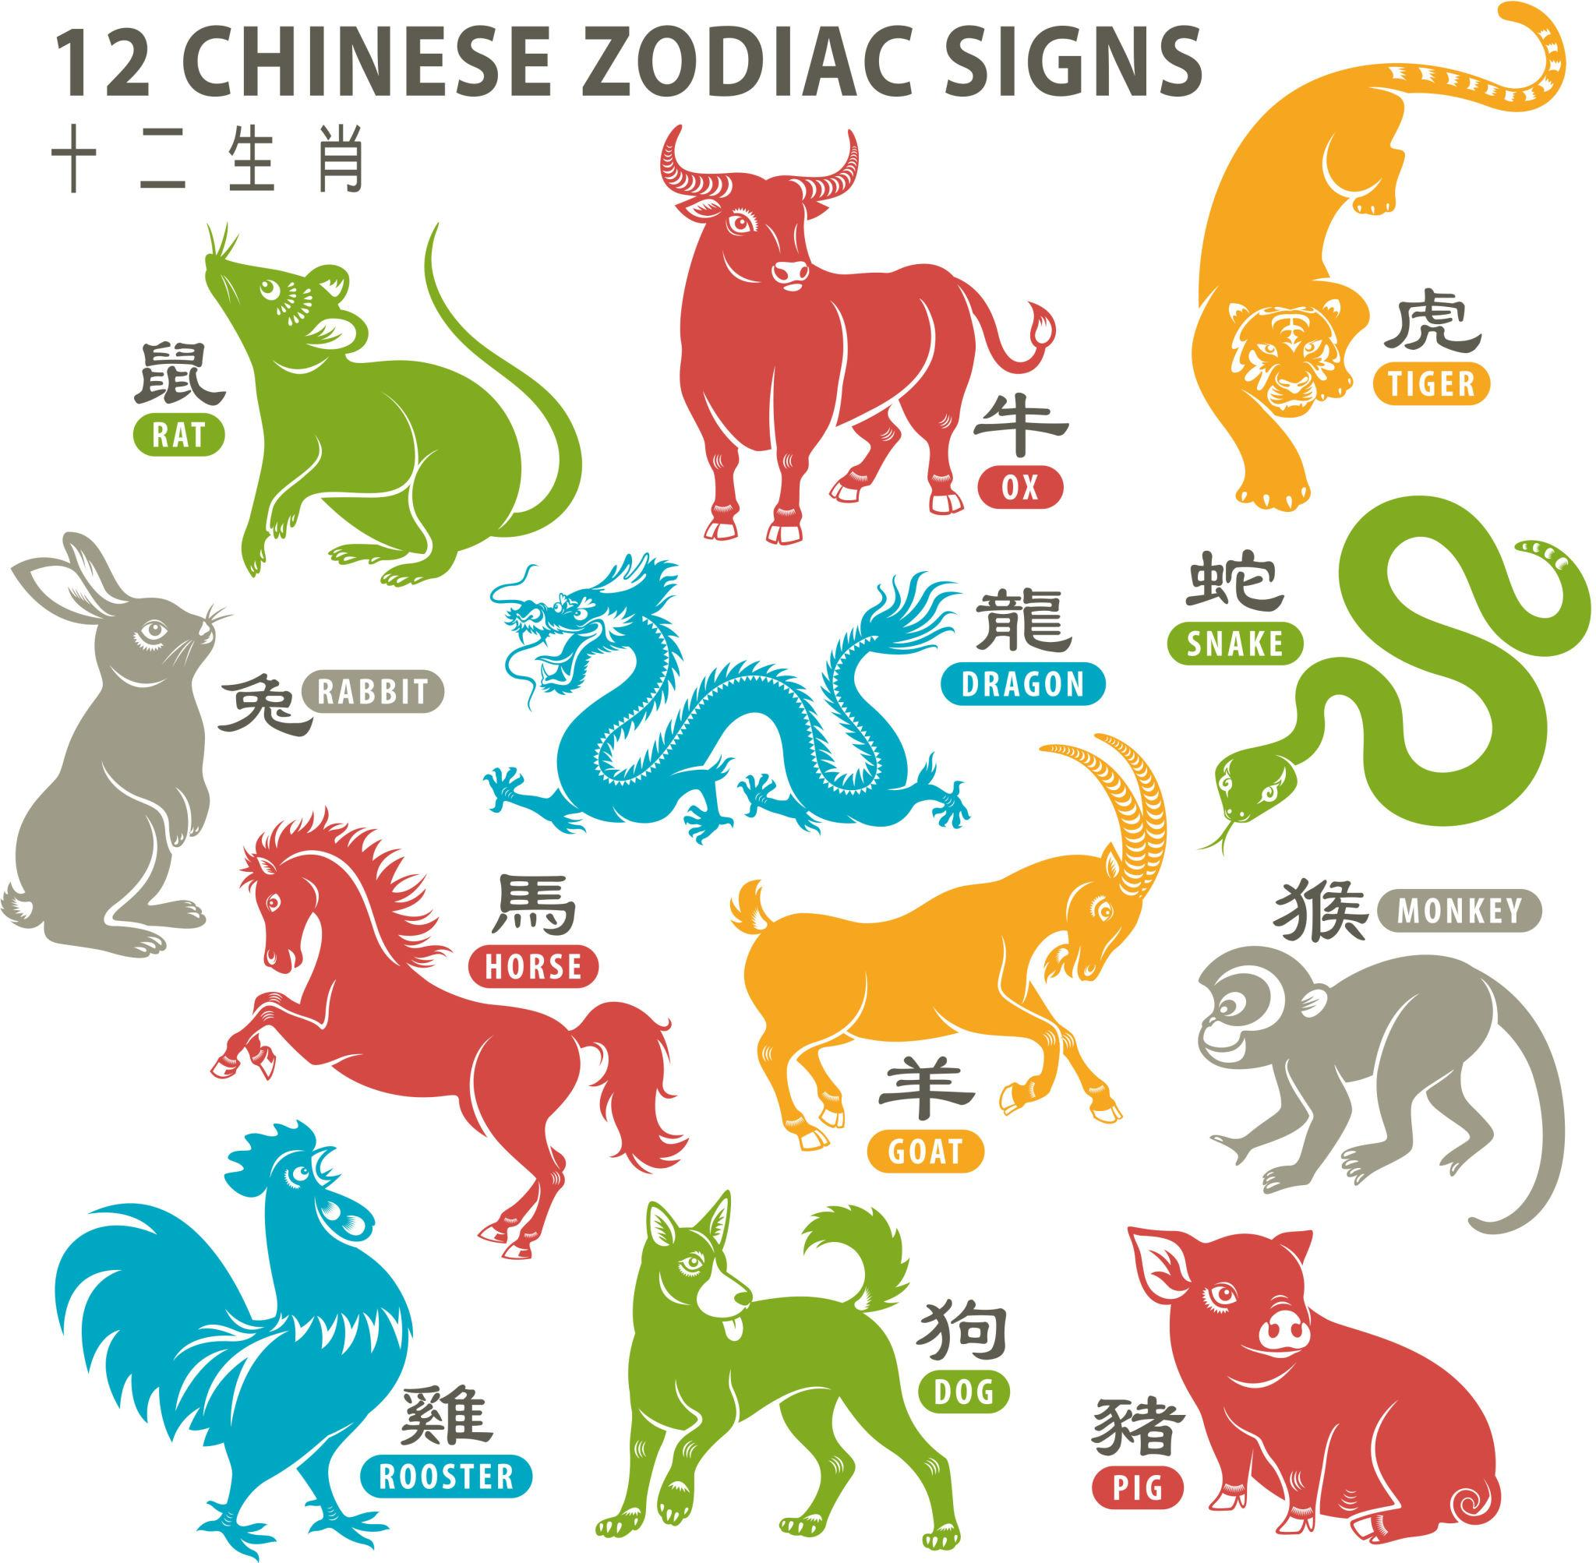
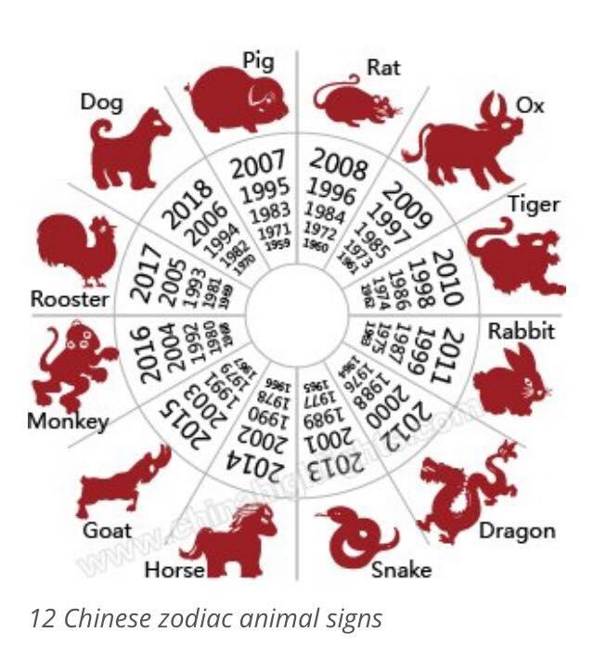
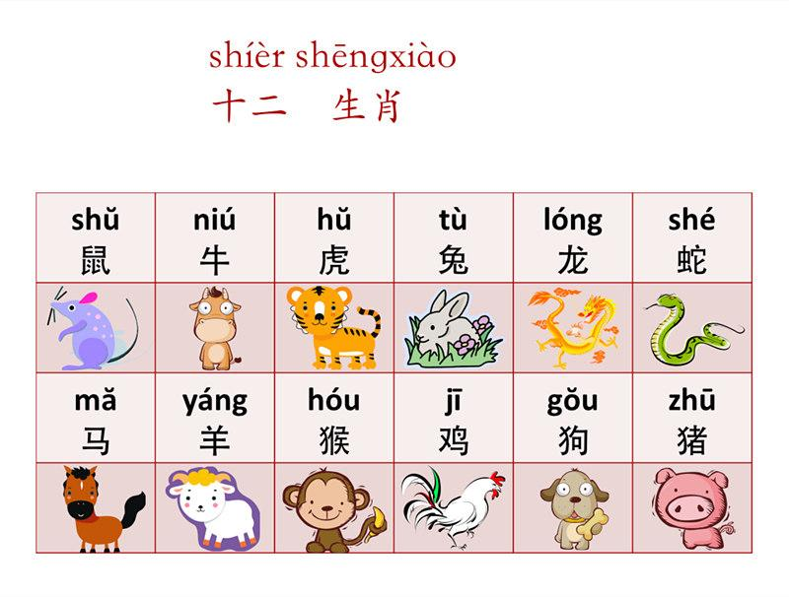
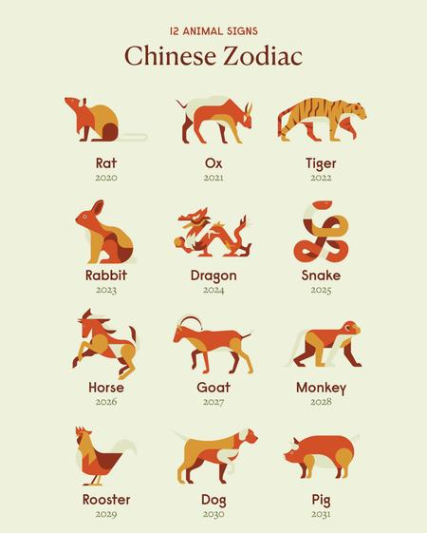
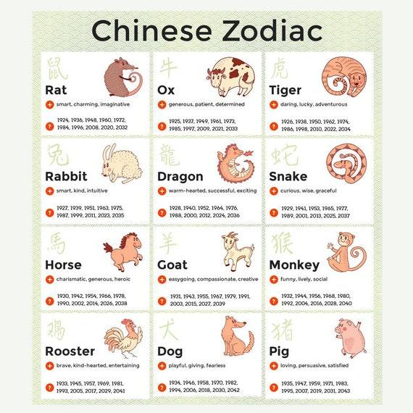
One of the best-known features of the Chinese Calendar is the 12-year zodiac cycle.
The twelve zodiac animals are:
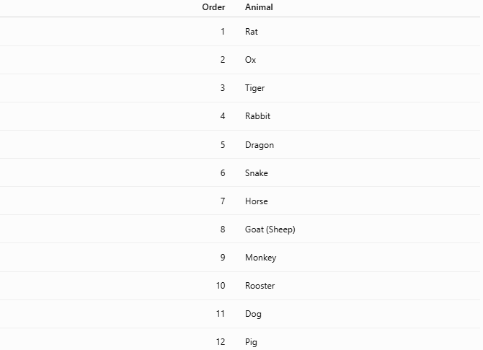
Order | Animal
1 | Rat
2 | Ox
3 | Tiger
4 | Rabbit
5 | Dragon
6 | Snake
7 | Horse
8 | Goat (Sheep)
9 | Monkey
10 | Rooster
11 | Dog
12 | Pig
Each lunar year is associated with one of these animals.

Heavenly Stems and Earthly Branches
# Source: AI Source: Provided by: [Data Path: Persons Table -> ID Column: 1, Name_En Column: Motasem Essam] -> From: [ChatGPT] on [7/17/2026]
In addition to the zodiac animals, the Chinese Calendar uses a traditional cycle of:
- 10 Heavenly Stems
- 12 Earthly Branches
Together they create a repeating 60-year cycle, with each year assigned a unique combination.

Major Festivals
# Source: AI Source: Provided by: [Data Path: Persons Table -> ID Column: 1, Name_En Column: Motasem Essam] -> From: [ChatGPT] on [7/17/2026]
The Chinese Calendar determines the dates of many traditional festivals, including:
- Chinese New Year (Spring Festival)
- Lantern Festival
- Dragon Boat Festival
- Mid-Autumn Festival
- Double Ninth Festival
Because these festivals are based on the lunisolar calendar, their Gregorian dates change each year.

Date Format
# Source: AI Source: Provided by: [Data Path: Persons Table -> ID Column: 1, Name_En Column: Motasem Essam] -> From: [ChatGPT] on [7/17/2026]
Traditional dates are commonly written using:
- Lunar year
- Month number
- Day number
Example:
- Year of the Dragon
- 8th Lunar Month
- 15th Day

Applications
# Source: AI Source: Provided by: [Data Path: Persons Table -> ID Column: 1, Name_En Column: Motasem Essam] -> From: [ChatGPT] on [7/17/2026]
The Chinese Calendar is used for:
- Traditional festivals
- Cultural celebrations
- Religious observances
- Family events
- Agricultural planning
- Zodiac calculations
- Historical records

Advantages
# Source: AI Source: Provided by: [Data Path: Persons Table -> ID Column: 1, Name_En Column: Motasem Essam] -> From: [ChatGPT] on [7/17/2026]
The Chinese Calendar:
- Maintains lunar months.
- Keeps festivals aligned with the seasons.
- Preserves cultural traditions.
- Supports agricultural planning.
- Provides the traditional zodiac cycle.

Limitations
# Source: AI Source: Provided by: [Data Path: Persons Table -> ID Column: 1, Name_En Column: Motasem Essam] -> From: [ChatGPT] on [7/17/2026]
The Chinese Calendar:
- Is more complex than the Gregorian Calendar.
- Requires leap months.
- Is not the standard civil calendar for most international purposes.
- Has changing festival dates in the Gregorian Calendar.

Comparison with Other Calendar Systems
# Source: AI Source: Provided by: [Data Path: Persons Table -> ID Column: 1, Name_En Column: Motasem Essam] -> From: [ChatGPT] on [7/17/2026]
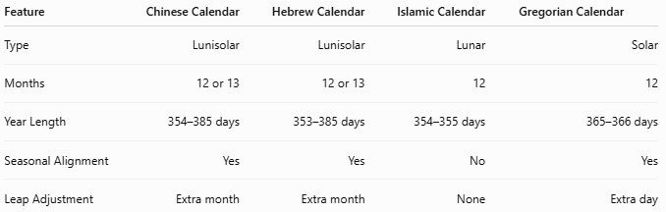
Feature | Chinese Calendar | Hebrew Calendar | Islamic Calendar | Gregorian Calendar
Type | Lunisolar | Lunisolar | Lunar | Solar
Months | 12 or 13 | 12 or 13 | 12 | 12
Year Length | 354–385 days | 353–385 days | 354–355 days | 365–366 days
Seasonal Alignment | Yes | Yes | No | Yes
Leap Adjustment | Extra month | Extra month | None | Extra day

Common Mistakes
# Source: AI Source: Provided by: [Data Path: Persons Table -> ID Column: 1, Name_En Column: Motasem Essam] -> From: [ChatGPT] on [7/17/2026]
- Confusing the Chinese Calendar with a purely lunar calendar.
- Assuming Chinese New Year has a fixed Gregorian date.
- Believing leap months occur at a fixed position every cycle.
- Confusing zodiac years with Gregorian years.

Key Points
# Source: AI Source: Provided by: [Data Path: Persons Table -> ID Column: 1, Name_En Column: Motasem Essam] -> From: [ChatGPT] on [7/17/2026]
- The Chinese Calendar is a lunisolar calendar.
- It combines:
  - Lunar months
  - Solar seasonal alignment
- It contains:
  - 12 months in common years.
  - 13 months in leap years.
- A leap month keeps the calendar synchronized with the seasons.
- It includes:
  - The 12-animal zodiac cycle
  - The 60-year Heavenly Stem–Earthly Branch cycle
- It determines the dates of important traditional Chinese festivals.

Conclusion
# Source: AI Source: Provided by: [Data Path: Persons Table -> ID Column: 1, Name_En Column: Motasem Essam] -> From: [ChatGPT] on [7/17/2026]
The Chinese Calendar is one of the world's oldest continuously used lunisolar calendars, blending the cycles of the Moon and the Sun to keep months tied to lunar phases while preserving seasonal consistency. Its use of leap months, the 12-animal zodiac, and the 60-year cyclical system makes it both astronomically practical and culturally significant. Although the Gregorian Calendar is now the standard for civil use in China, the traditional Chinese Calendar remains central to festivals, family celebrations, and cultural heritage.

